1. Using **OpenAPI Specification Doc**, we can mock the APIs so that consumers can consume the mocked APIs instead of waiting for Producer to complete the APIs work.  
   This way consumers can develop in parallel.
2. To mock APIs, many options but we will use Open-Source **Prism**.
3. **Prism**:
   1. Open-Source HTTP Mock Server which can mimic your APIs behaviour as if they are implemented with real java/python code.
   2. Supports Swagger 2/3 Versions.
   3. 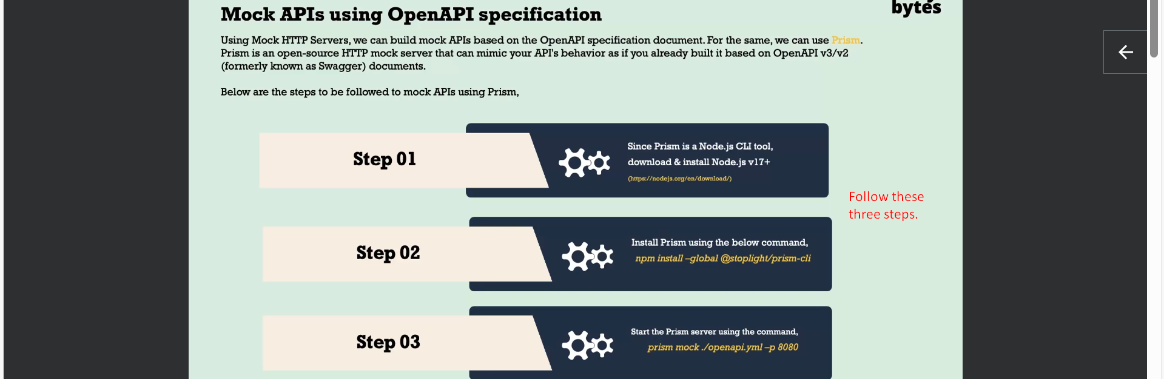
4. 
5.   
   Use **sudo** before command in case of access issue.
6. 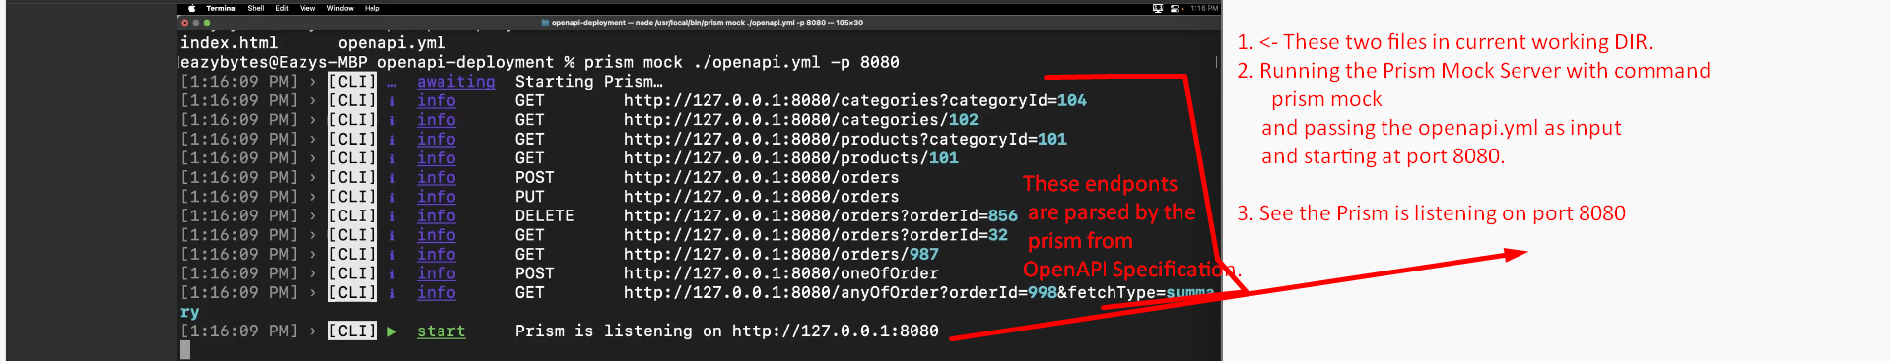
7. 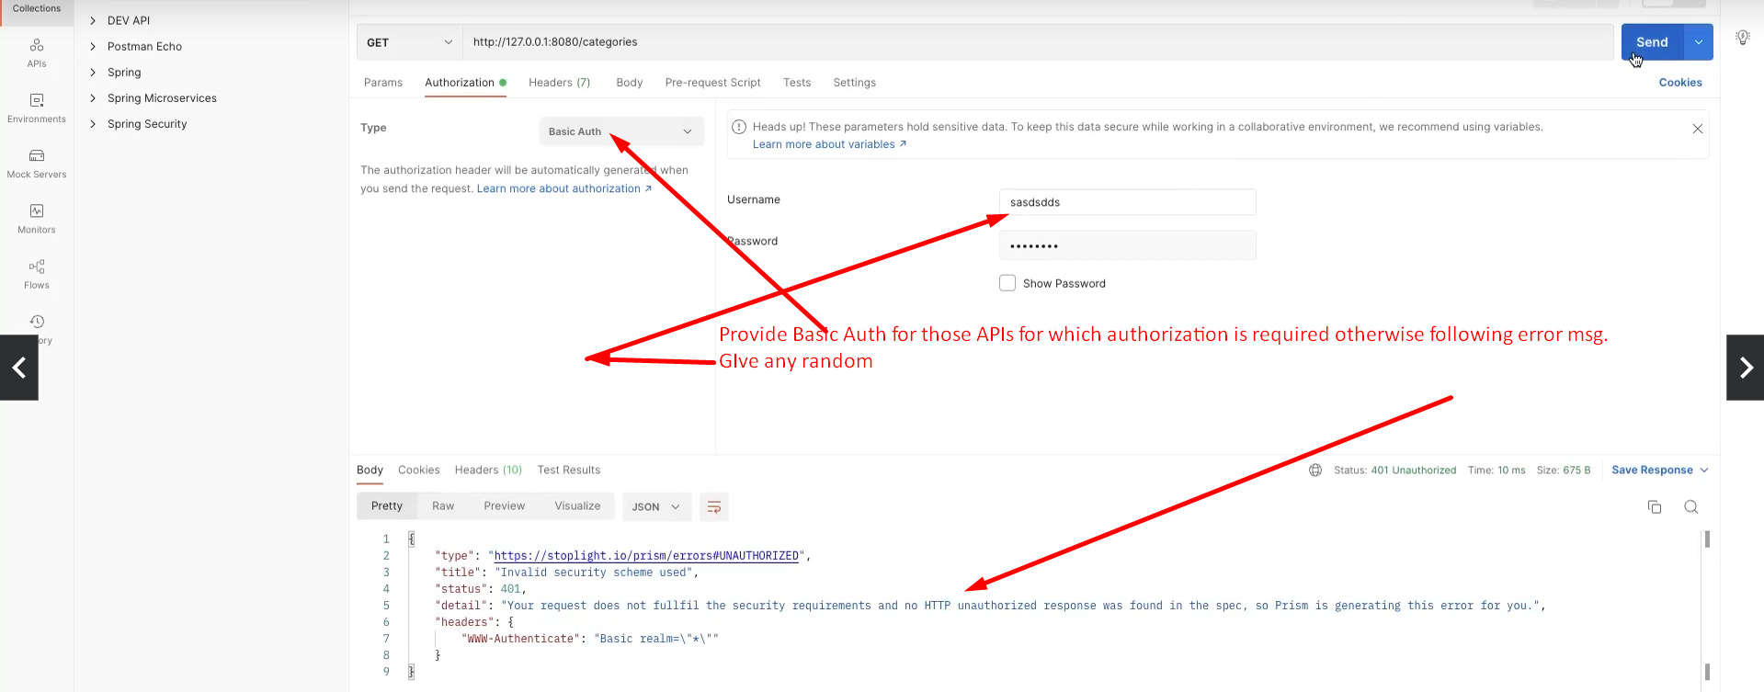
8. NOTE that the response returned by the PRISM Mock Server is provided from the field “examples” as we can see from the below snapshot.  
   It may be possible that multiple examples are provided then 1st one will be returned by the PRISM Mock Server.   
   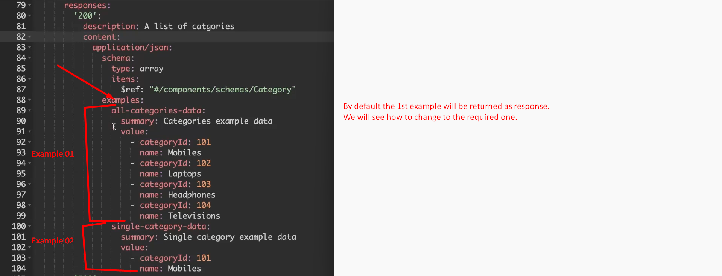
9. By default the 1st example will be returned.   
   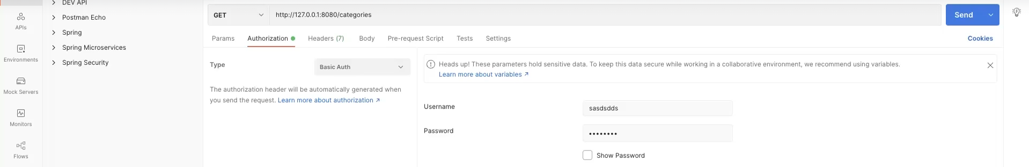  
   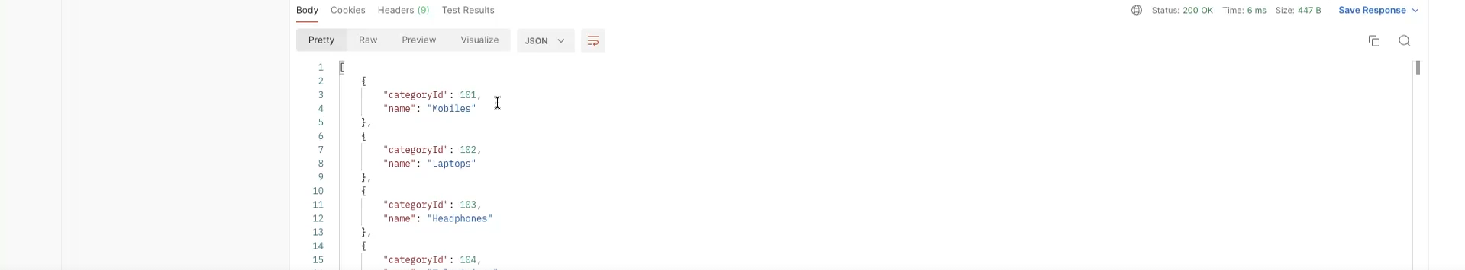
10. let’s see how to return a specific example instead of the default 1st one.  
    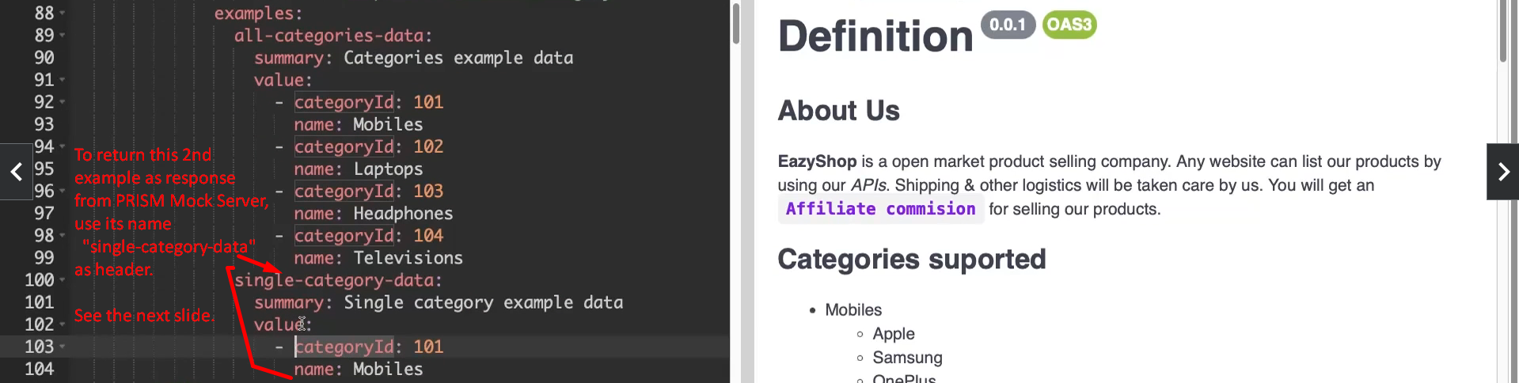  
      
      
    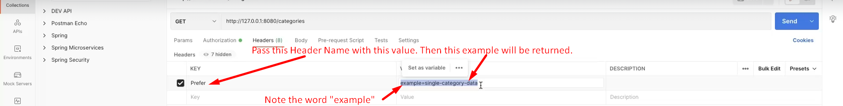  
    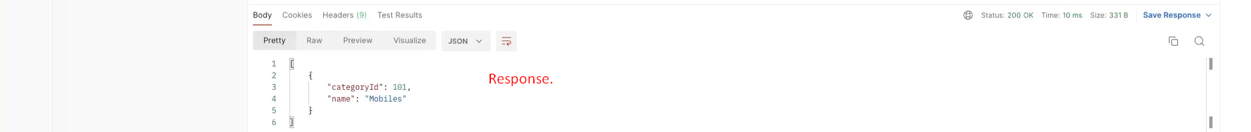  
      
      
      
      
      
    **To return response configured for 500 HTTP Status Code**.  
      
      
    